Energy Use in Transportation
(Excerpt from NGS Environmental Literacy Teachers Guide Series,
Energy Potential: A Guide for Teaching Energy in Grades 3 to 8)

People have many ways of getting themselves and their stuff around: cars, trucks, trains, planes, buses, bikes and walking to name a few. While transportation is crucial to our personal lives and economy, it is also a significant source of carbon dioxide emissions. Transportation accounts for about one-third of the total greenhouse gas emissions in the United States, second only to electricity generation. Most of the carbon dioxide emissions in transportation are directly due to burning fossil fuels, like gasoline.

The largest sources of transportation-related carbon dioxide emissions in the United States in 2006 were personal vehicles like passenger cars, trucks, SUVs and minivans. Together personal vehicle emissions made up two-thirds of transportation-related carbon dioxide emissions. For the remaining one-third, the largest sources were freight trucks and commercial aircraft. It’s important to realize that different types of transportation cause different amounts of carbon emissions depending on the source of energy for movement and how it is used. This reading provides an account of how energy is used during various modes of transportation, and of the carbon dioxide emissions that occur during these types of energy use.

Walking and Biking
The most common way for people to get around is by walking. When a person is walking, they use their leg muscles and bones rather than an engineered machine to get from one place to another. Chemical energy is stored in a person’s body in C-C and C-H bonds of fat and carbohydrate molecules. In a person’s body, this stored chemical energy is converted into motion energy with each step. Some of the chemical energy also gets transformed into heat energy during body movement.
A similar thing happens when a person uses their legs to ride a bike. Chemical energy stored in a person’s body is used to move their legs on the pedals. On a bike, motion energy from the pedals results in movement of gears and wheels, which result in faster and more efficient movement. A bike also gets some added benefit from gravitational energy when it goes down hills.
A person who is walking or biking creates very few carbon emissions, although some carbon dioxide is released as a result of respiration. The carbon atoms in carbon dioxide come from fat or carbohydrates that are oxidized during cellular respiration. In cellular respiration, the stored energy in fats or carbohydrates is transformed into motion energy and heat.

What Happens in Different Types of Cars and Trucks?
Combustion Engine Vehicles. Most cars and trucks have combustion engines that rely on fossil fuels like gasoline and diesel, both of which have a large amount of stored chemical energy. Combustion is a process in which the chemical energy in these fuels is transformed into another type of energy. Combustion of fuels also yields carbon dioxide and water vapor (through the rearrangement of atoms that occurs during the chemical reaction of combustion).
Combustion occurs inside an engine, in what is called a combustion chamber. When fuel and air are mixed, the combustion chemical reaction creates a great deal of heat and pressure from the water vapor and CO₂ given off by the reaction. This heat and pressure are used to produce motion energy, which is observable as the movement of a piston, turbine, or nozzle.

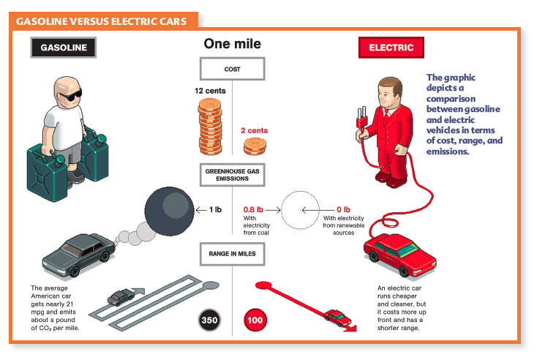
Electric Vehicles. Many automobile companies are currently working on creating a new generation of transportation engines that rely on fewer fossil fuels, but still have competitive motion performance. Electric cars work very differently than internal combustion engines. They use electric motors instead of combustion motors. In electric motors, there are different ways to generate the electricity needed by the motor. One common way to generate the electricity is by using stored chemical energy in batteries. These battery packs are rechargeable, which is why electric cars must be plugged in overnight.
When a battery is being charged, electrical energy is being transformed into stored chemical energy in the battery. In turn, when the car is running, stored chemical energy in the battery is transformed into electrical energy used to power the electric motor in the car. Next, the electric motor transforms electrical energy into motion energy. Electrical energy used in an electric car must ultimately be supplied by a power plant, which may use a variety of types of energy to transform into electricity.

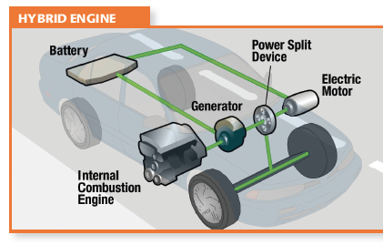
Hybrid Vehicles. As the name implies, hybrid engines use a combination of an internal combustion engine and an electric engine, with a generator between the two. There are many types of hybrid vehicles. The most popular of these vehicles is a full hybrid like the Toyota Prius or Ford Fusion. Some key features of hybrid engines are 1) the use of regenerative braking, where the motion energy from braking is changed into chemical energy that can be stored in batteries, and 2) the automatic shut off of the combustion engine when the car is stopped. Automatic shut off is why hybrid cars are more efficient in cities where braking and traffic stops are more frequent. A hybrid vehicle can either draw from energy stored in the batteries (which came from motion power generated by braking), or from chemical energy found in the combustion fuel source. Depending on the type of driving, a hybrid motor undergoes different energy transformations that result in motion energy of the car.

How Do Planes and Trains Work?

Airplanes, buses and diesel trains (like Amtrak) have combustion engines that work in a similar way to combustion engines in cars and trucks; fossil fuel-based chemical energy is converted into motion energy. However, some trains (usually rail transits around cities) run on electrical energy, converting electricity to motion energy. Some trains have a battery that can be re-charged and some trains have a stationary wire that provides electrical energy, but in both of these cases electrical energy must ultimately be provided by power plants. Power plants can produce electricity from fossil fuels like coal, or from nuclear energy or hydropower.
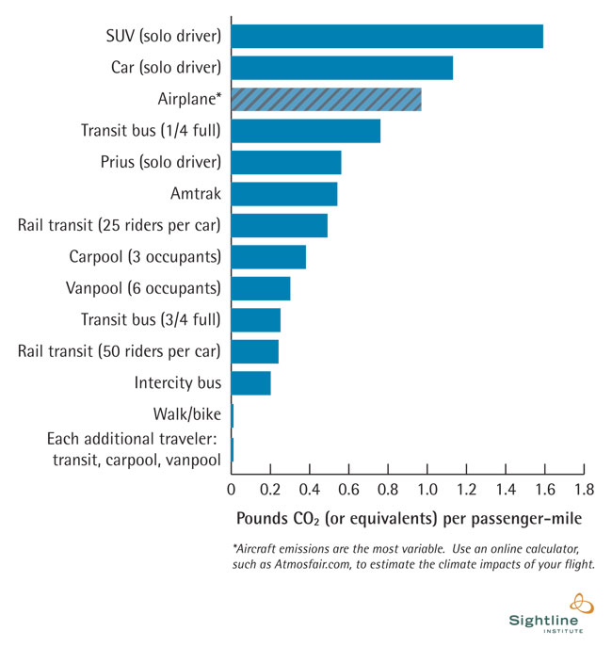
How Much Carbon Emissions Are Produced by Moving One Mile?
There is a lot of variation in the amount of carbon emissions produced when a person travels one mile, depending on the method of transportation they choose. Large vehicles are heavier and generally require more fuel to go the same distance. For example, more carbon emissions are produced through traveling the same distance in a large car versus a small car. Some types of transportation use less fuel to go the same distances because they have a more efficient engine. For example, a hybrid car like the Prius releases fewer pounds of CO₂ per passenger per mile than a regular car. Fewer carbon emissions are produced when people choose to share the same vehicle, for example through carpooling or taking the bus, than when they choose to drive alone. Think about the next trip that you will be taking. Are there different ways you can get from one place to another? Can you estimate the different amounts of carbon emissions associated with different types of travel?

